RESTAURANT TABLE RESERVATION AND MANAGEMENT SYSTEM
Software Engineering Case Study

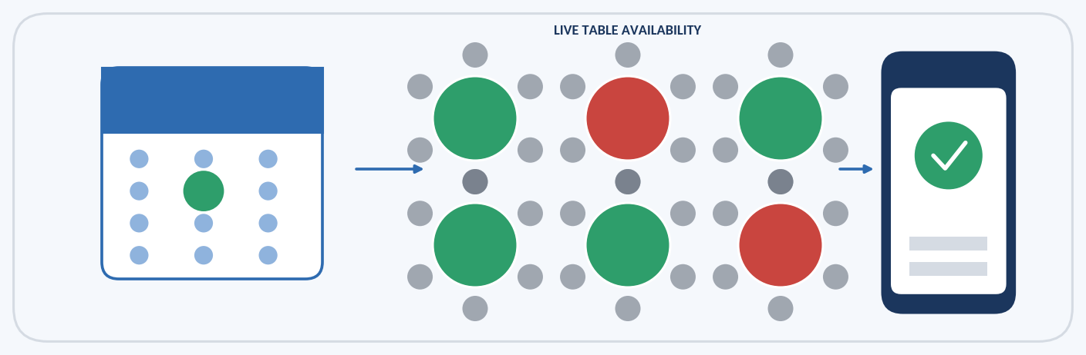

Student Name | Hemapriya J
Register Number | 192521431
Department | Information Technology
Institution | SIMATS Engineering College
Academic Year | 2026

Introduction and Problem Statement

Introduction
A Restaurant Table Reservation and Management System (RTRMS) is a software application that allows customers to check the availability of tables, reserve a table for a chosen date and time, and cancel the reservation when their plans change. At the same time, it gives restaurant staff a single place to maintain table details, supervise bookings and view customer information. The system replaces handwritten registers and telephone-based bookings with a centralized, database-driven solution.
A restaurant must share a limited number of tables among many customers in a time-sensitive environment. Without automation, staff spend valuable time answering calls and verifying registers, and mistakes such as double booking directly affect the reputation of the business. This case study applies Software Engineering principles, namely requirements analysis, feasibility study, design modelling, database design and testing, to develop a reliable RTRMS.

Need for the System
An automated reservation system is needed for the following reasons:
    - Online table availability: customers can check free tables at any time without calling the restaurant.
    - Faster reservations: a booking is completed in a few steps instead of a long phone conversation.
    - Reduced waiting time: pre-booked guests are seated promptly on arrival.
    - Better customer experience: instant confirmation and easy cancellation build trust.
    - Easy booking management: staff can view, modify and cancel bookings from one screen.
    - Centralized data management: customer, table and booking data are stored securely in one database.
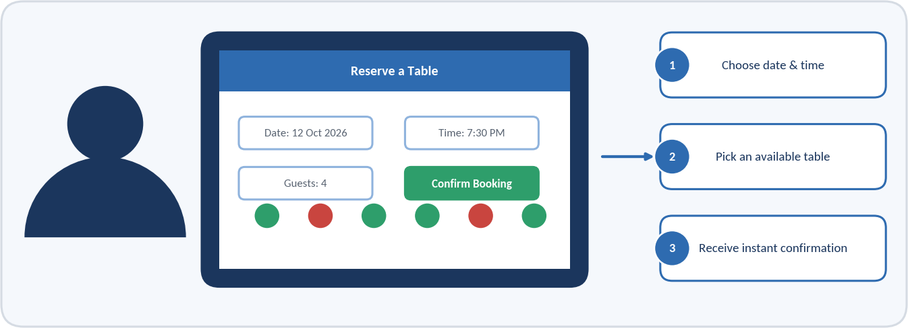
Figure 1: Customer Using a Digital Restaurant Reservation System

Problem Statement
“Develop a system that enables customers to view restaurant availability, reserve tables, cancel reservations, and allows restaurant staff to manage tables and bookings.”
In the existing arrangement, reservations are taken through phone calls or walk-in requests and are written in manual registers. This leads to double booking, human errors, difficulty in checking availability, difficult cancellation handling and poor record maintenance, as summarised in Figure 2.
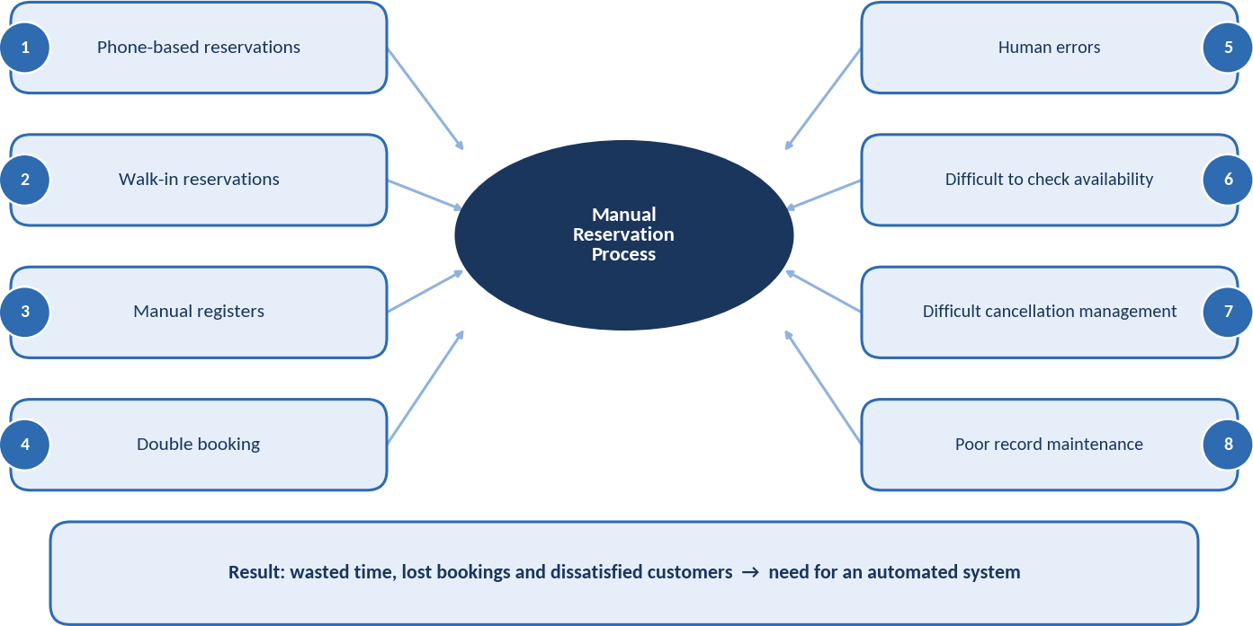
Figure 2: Problem Analysis of the Manual Reservation System
Each of these problems is addressed by a specific feature of the proposed system, as explained in the following chapters.

Case Study Analysis and Existing System

Case Study Scenario
Consider a family restaurant with twelve tables of different seating capacities. Customers reserve tables by calling the restaurant or by visiting in person. The receptionist notes the customer’s name, phone number, date, time and number of guests in a paper register and assigns a table after checking earlier entries. On weekends and festival days the number of calls rises sharply and the receptionist must also attend to walk-in guests, which makes the process slow and error-prone.

Stakeholders
Table 1: Stakeholders of the System
Stakeholder | Role | Interest in the System
Customer | Views availability, reserves and cancels tables | Quick, reliable and convenient booking
Restaurant Staff | Handles daily bookings and table status | Accurate tools that reduce manual work
Restaurant Manager / Admin | Supervises operations and reviews reports | Control, reports and better table utilisation

Existing System
In the traditional process, a customer contacts the restaurant by telephone or walks in. The staff member checks the manual register to find a free table, records the booking by hand and allocates the table. The process is illustrated in Figure 3.
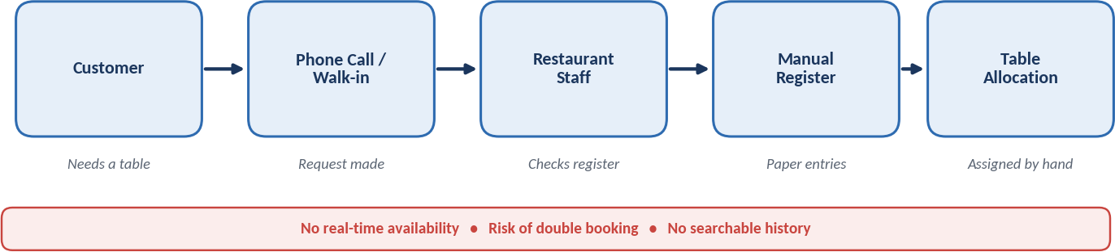
Figure 3: Existing (Manual) Reservation Process
Because every step depends on a person reading and writing a paper record, the customer receives no instant confirmation and the restaurant has no reliable view of its current bookings.

Problems in the Existing System

    - Manual work: every booking is written and searched by hand.
    - Double booking: the same table can be promised to two customers.
    - Data errors: names, numbers and timings are misheard or mis-written.
    - Time consumption: phone calls and register checking delay both staff and customers.
    - Poor tracking: past bookings are hard to trace or summarise.
    - Difficult cancellation management: cancelled slots are not released in time.

Table 2: Comparison of Existing and Proposed Systems
Existing System | Proposed System
Manual booking | Digital booking
Difficult availability checking | Real-time availability
Higher chance of errors | Reduced errors
Manual records | Database records
Slow process | Faster process

Proposed System and Objectives

Proposed System
The proposed system is a web-based application with two user roles. Customers register or log in, search by date and time, view the tables that are free for that slot, select a suitable table and confirm the reservation. Restaurant staff use a separate management portal to maintain table details and to monitor and manage bookings. The working of the customer side is shown in Figure 4.
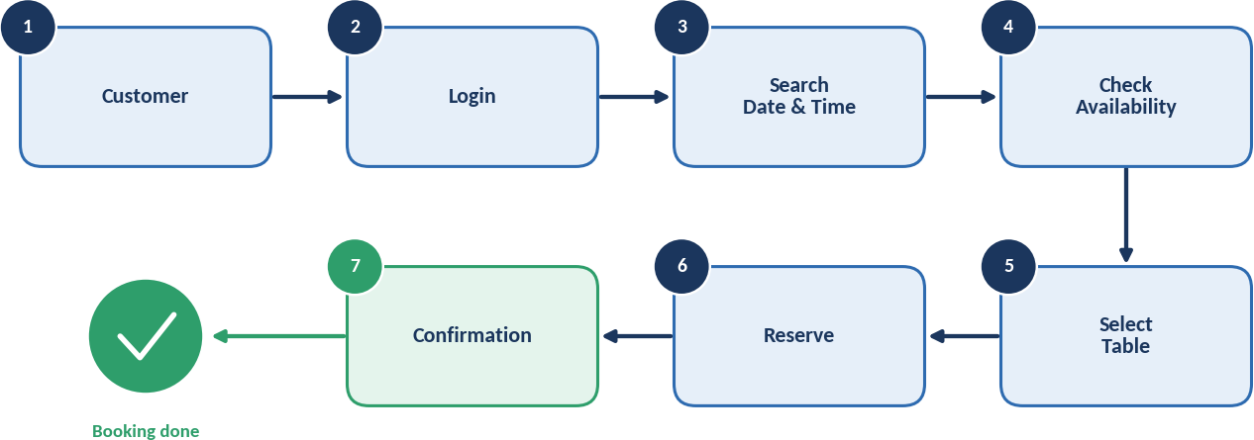
Figure 4: Proposed System Workflow for a Customer Reservation
When the customer confirms a booking, the system stores the reservation in the database, marks the selected table as reserved for that time slot and displays a confirmation. Because availability is checked against the database every time, two customers can never receive the same table for the same slot.

Objectives of the System

- View table availability
- Reserve tables
- Cancel reservations
- Manage restaurant tables
- Manage bookings
- Prevent double booking
- Maintain reservation history
- Reduce manual work
- Improve customer experience

The staff-side interface through which the tables and bookings are managed is illustrated in Figure 5.
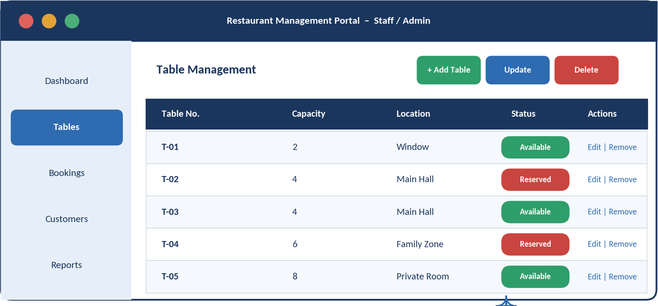
Figure 5: Restaurant Management Software Interface (Table Management Screen)

Requirements Analysis

Functional Requirements
Functional requirements describe the services the system must provide. They are divided between the customer and the staff/admin roles, as shown in Figure 6.
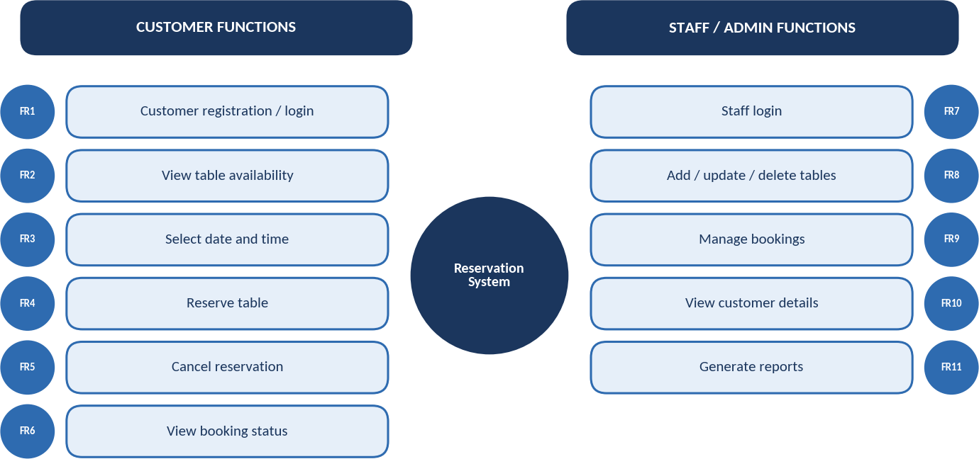
Figure 6: Functional Requirements Overview
Eleven functional requirements (FR1–FR11) cover registration, availability search, reservation and cancellation for customers, and table, booking, customer and report management for staff.

Non-Functional Requirements
Non-functional requirements define the quality attributes of the system. The system must be responsive (performance), protect data (security), run without failures (reliability), be easy to learn (usability), be accessible whenever customers need it (availability), grow with more tables and users (scalability) and be simple to update (maintainability).

Feasibility Study

A feasibility study checks whether the proposed system can be developed and operated successfully. Five aspects were examined.

Technical Feasibility
The system can be built with widely available technologies: HTML, CSS and JavaScript for the interface, a server-side language such as Java or Python for the business logic, and a relational database such as MySQL. An ordinary web server and a modern browser are sufficient, so no special hardware is needed.

Economic Feasibility
Development cost is limited to developer effort, hosting and domain charges, and open-source tools remove licence fees. Maintenance cost is low. The benefits are fewer lost bookings, reduced staff workload and better table utilisation, so the investment is recovered quickly.

Operational Feasibility
The interface follows familiar web-form conventions, so customers and staff need very little training. The system fits the restaurant’s existing booking routine and reduces, rather than increases, manual effort.
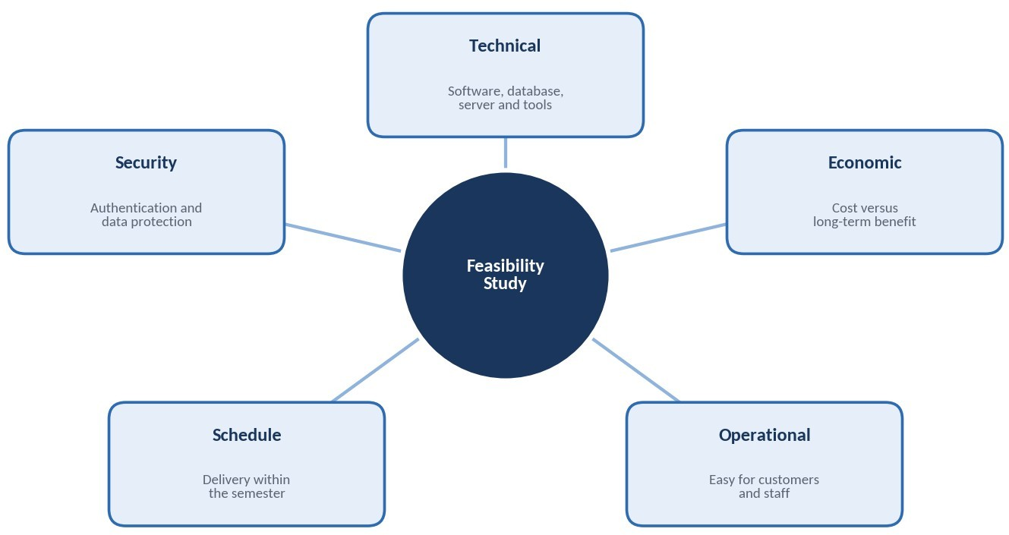
Figure 7: Feasibility Study Overview

Schedule Feasibility
The project is divided into analysis, design, implementation, testing and deployment phases. With a small team, the system can be completed within one academic semester of about 12 to 14 weeks.

Security Feasibility
Users are authenticated with unique credentials, and role-based authorization restricts administrative functions to staff. Passwords are stored in hashed form, communication uses HTTPS, and regular database backups protect customer data.
Table 4: Feasibility Comparison
Feasibility | Key Consideration | Result
Technical | Open-source tools and standard hardware are enough | Feasible
Economic | Low development and maintenance cost with high return | Feasible
Operational | Simple to learn and use for customers and staff | Feasible
Schedule | Can be completed within 12–14 weeks | Feasible
Security | Authentication, authorization and data protection | Feasible

System Design – Architecture and Use Case

System Architecture
The system follows a three-tier architecture that separates the user interface, the business logic and the data. Customers and staff interact only with the presentation tier, which sends their requests to the application tier.
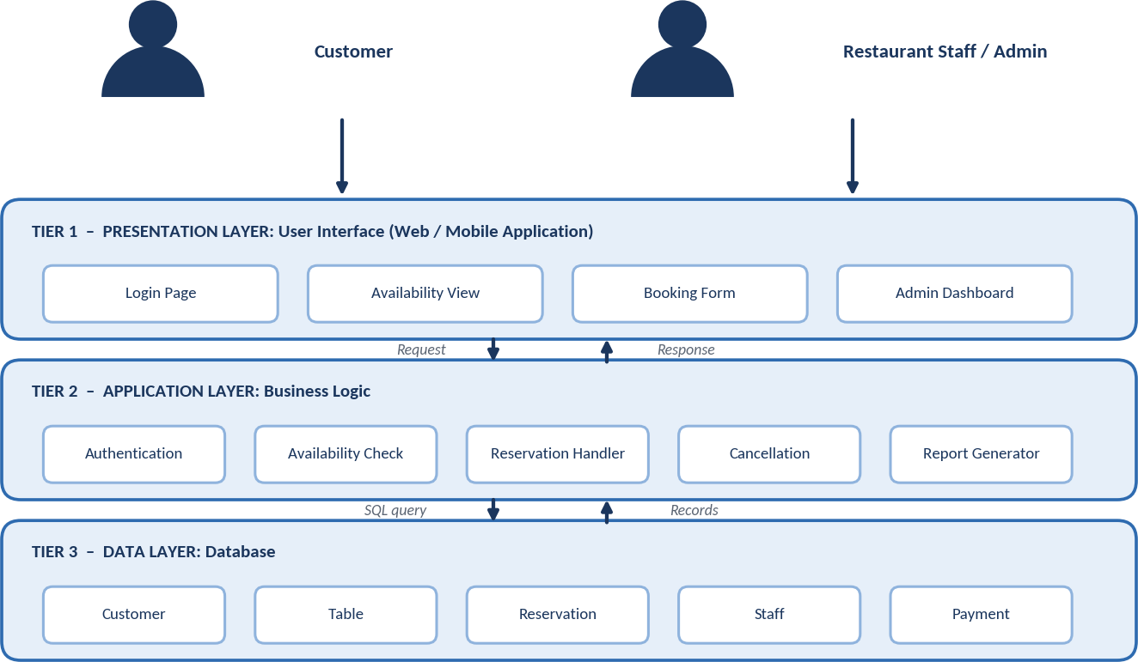
Figure 8: Three-Tier System Architecture
The application tier validates each request, checks availability, creates or cancels reservations and generates reports. It reads and writes records in the data tier, which stores the customer, table, reservation, staff and payment data. This separation makes the system easier to maintain and secure.

UML Use Case Diagram
The use case diagram identifies two actors, the Customer and the Restaurant Staff/Admin, and the functions available to each.
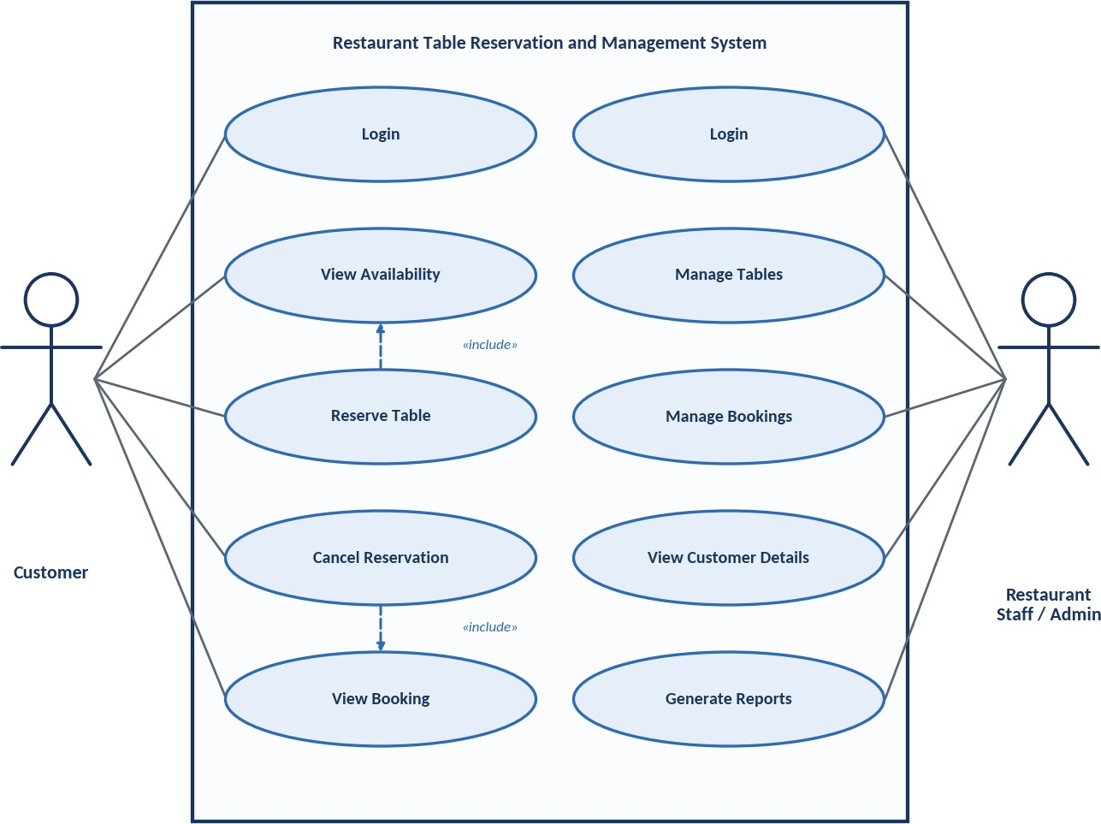
Figure 9: UML Use Case Diagram of the Reservation System

DFD Level 0 (Context Diagram)
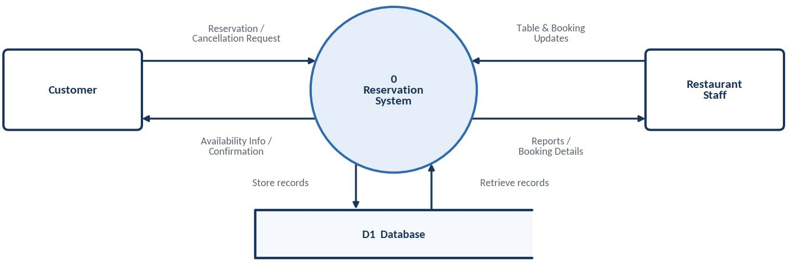

DFD Level 1
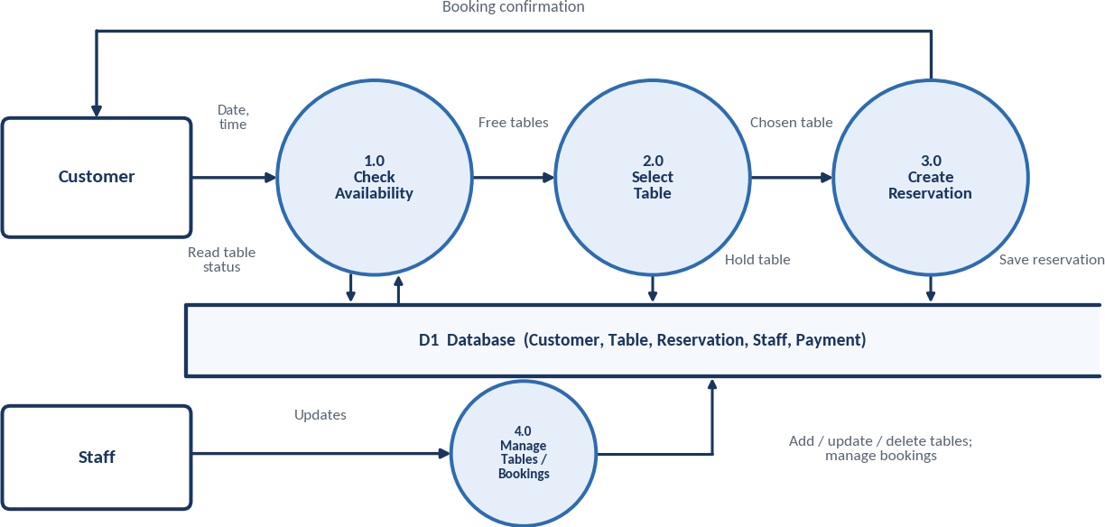

UML Activity Diagram

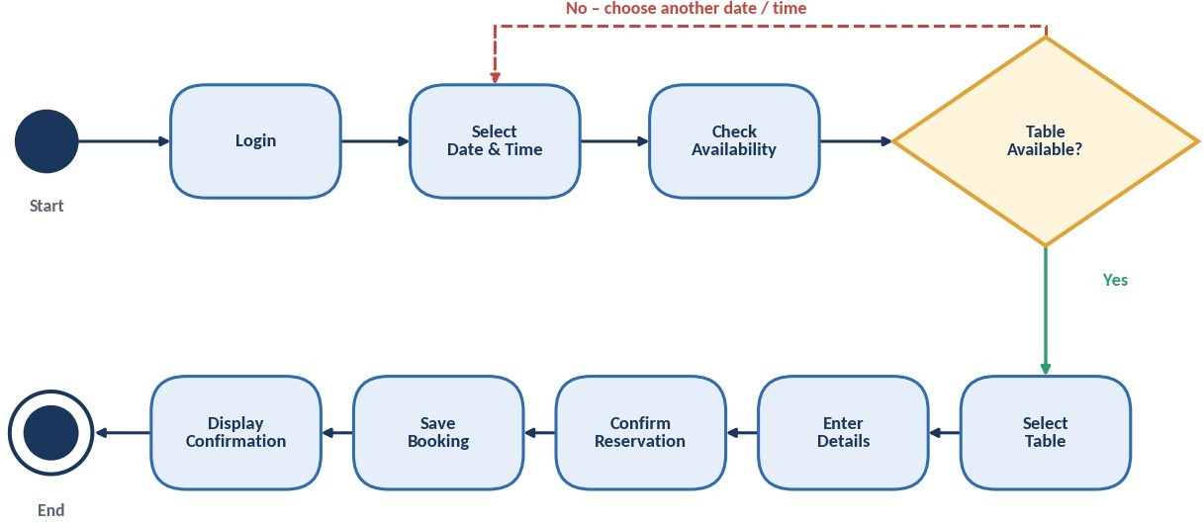

Database Design

Entity Relationship Diagram
The database is designed in relational form with five entities: CUSTOMER, TABLE, RESERVATION, STAFF and PAYMENT. Each entity has a primary key (PK), and the RESERVATION entity links customers and tables through the foreign keys (FK) Customer_ID and Table_ID.

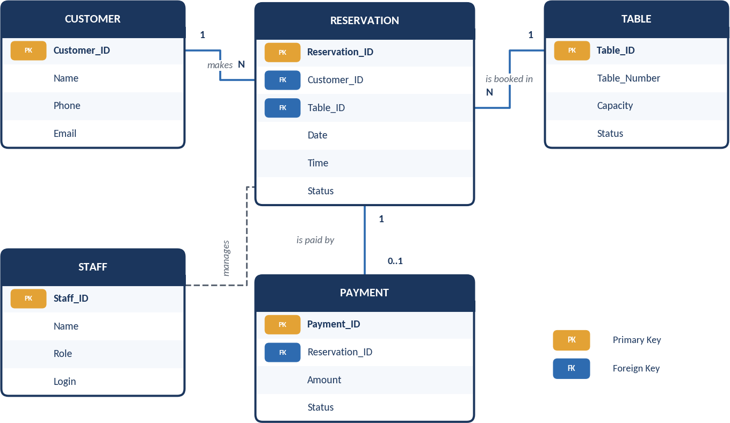
Figure 13: Entity Relationship (ER) Diagram
One customer can make many reservations, and one table can be booked many times at different time slots. Each reservation may have at most one payment record. Staff access is controlled by role-based authorization in the application tier, so it is shown as a dashed association. Since TABLE is a reserved word in SQL, the implementation names it RESTAURANT_TABLE.

Database Tables
Table 5: Database Table Structure
Table Name | Attributes | Primary Key | Foreign Key
CUSTOMER | Customer_ID, Name, Phone, Email | Customer_ID | –
TABLE | Table_ID, Table_Number, Capacity, Status | Table_ID | –
RESERVATION | Reservation_ID, Customer_ID, Table_ID, Date, Time, Status | Reservation_ID | Customer_ID → CUSTOMER; Table_ID → TABLE
STAFF | Staff_ID, Name, Role, Login | Staff_ID | –
PAYMENT | Payment_ID, Reservation_ID, Amount, Status | Payment_ID | Reservation_ID → RESERVATION

Integrity Constraints
    - Entity integrity: every table has a unique, non-null primary key.
    - Referential integrity: Customer_ID, Table_ID and Reservation_ID must refer to existing records.
    - Double-booking control: a unique constraint on Table_ID, Date and Time rejects a second active booking for the same slot.
    - Domain integrity: Status accepts only defined values such as Available, Reserved, Confirmed and Cancelled.

Module Design and Workflow

Major Modules

- Customer Management: registration and login.  - Table Availability Management: slot status.  - Reservation Management: create bookings.  - Cancellation Management: release tables. | - Staff/Admin Management: roles and access.  - Database Management: store and retrieve data.  - Report Management: booking reports.
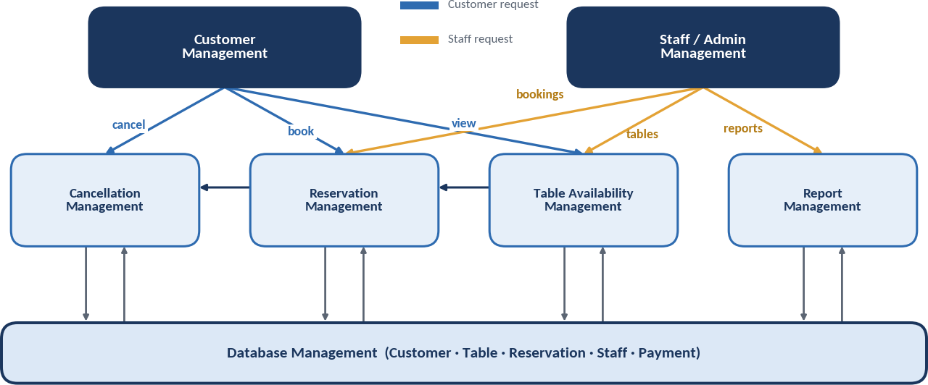
Figure 14: Module Interaction Diagram

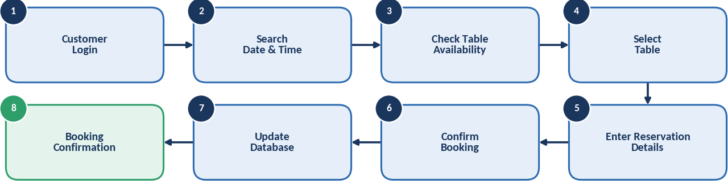
Complete System Workflow
Figure 15: Complete Reservation Workflow

Reservation Dashboard Mock-up
The dashboard gives staff a quick view of available and reserved tables, booking details, customer details and reservation status.

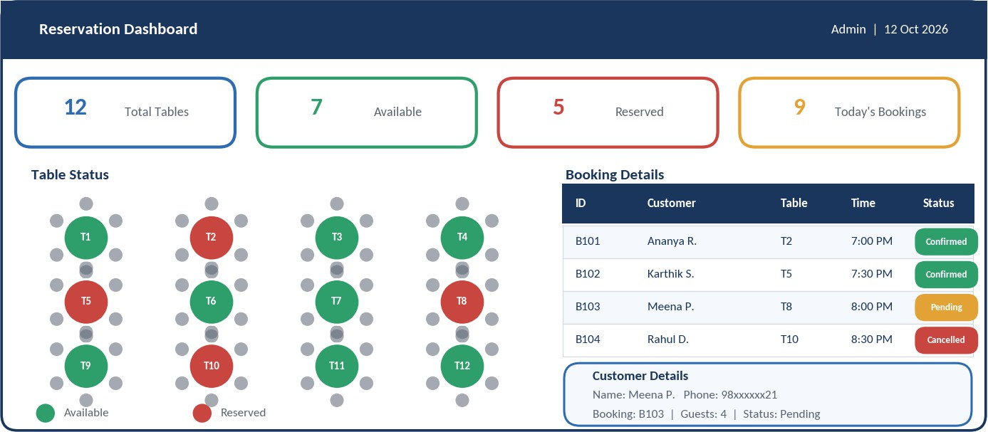
Figure 16: Restaurant Reservation Dashboard (Academic Mock-up)

Testing, Advantages and Limitations

Testing Process
Testing is carried out at four levels, from individual functions to final acceptance. Defects found during execution are logged, fixed and re-tested before the final test report is prepared.
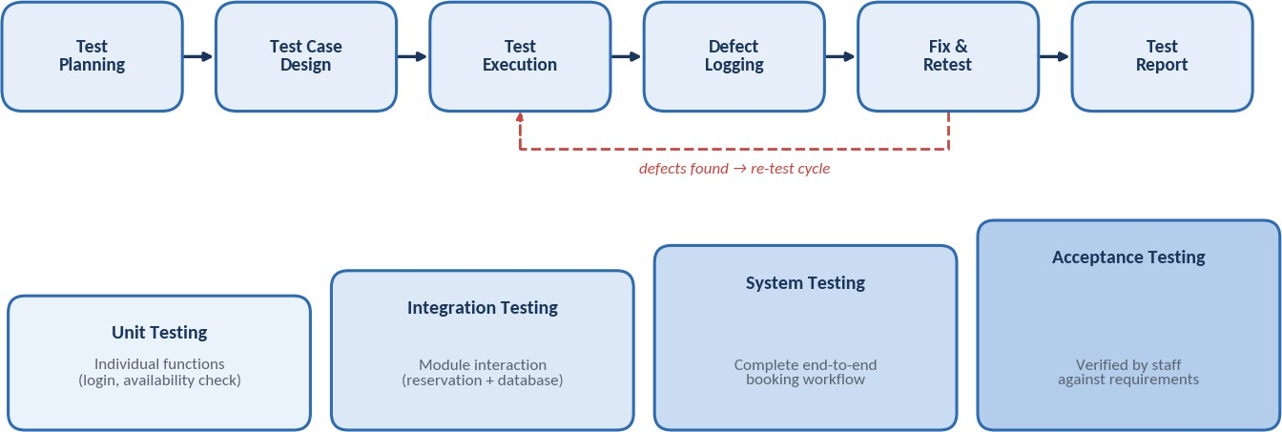

Table 6: Test Cases for the Reservation System

Test Case ID | Test Scenario | Expected Result
TC01 | Customer logs in with valid credentials | User is authenticated and the home page opens
TC02 | Login with an incorrect password | Error message is shown; access is denied
TC03 | Search availability for a valid date and time | List of free tables is displayed
TC04 | Reserve an available table | Reservation is saved and confirmation is shown
TC05 | Reserve a table already booked for the same slot | Booking is rejected; double booking is prevented
TC06 | Cancel an existing reservation | Status becomes Cancelled and the table is released
TC07 | Staff adds, updates or deletes a table | Table record is changed in the database
TC08 | Staff views booking and customer details | Correct details are displayed
TC09 | Generate a reservation report | Report is produced for the selected period
TC10 | Submit the booking form with empty fields | Validation message is displayed

Conclusion, Future Scope and References

Conclusion
This case study presented the analysis and design of a Restaurant Table Reservation and Management System. The study identified the weaknesses of the manual process and defined clear functional and non-functional requirements. It then confirmed feasibility and produced the architecture, use case, data flow, activity, ER and module designs, supported by a test plan.
The proposed system lets customers view availability, reserve and cancel tables online, and lets staff manage tables and bookings from one portal. By preventing double booking and keeping accurate records, it reduces manual work and improves customer satisfaction. The case study also shows how Software Engineering models guide the development of a dependable system from requirements to testing.

Future Enhancements
The system can be extended in later versions with the enhancements shown in Figure 18, such as online payment of booking deposits, SMS or e-mail reminders, a mobile application, waiting-list management and analytics to forecast demand.
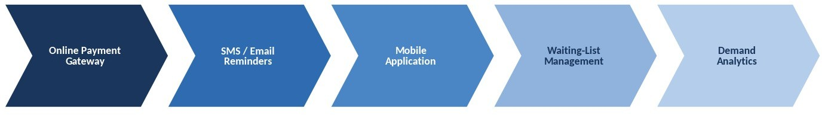

Figure 18: Future Enhancement Roadmap

References
- I. Sommerville, Software Engineering, 10th ed. Pearson, 2016.
- R. S. Pressman and B. R. Maxim, Software Engineering: A Practitioner’s Approach, 9th ed. McGraw-Hill, 2020.
- R. Elmasri and S. B. Navathe, Fundamentals of Database Systems, 7th ed. Pearson, 2016.
- G. Booch, J. Rumbaugh and I. Jacobson, The Unified Modeling Language User Guide, 2nd ed. Addison-Wesley, 2005.
- ISO/IEC/IEEE 29148:2018, Systems and Software Engineering – Life Cycle Processes – Requirements Engineering

